fws-I_Op_Distance TMS

Software Build Procedure

**Date: April 3, 2018**

**Prepared for:**

**INTERNAL USE ONLY**

**Prepared By:**



**Information & Electronic Systems Integration Inc.  
P.O. Box 868  
Nashua, NH 03060-0868**

**BAE Systems Proprietary Information**

**BAE Systems Information and Electronic Systems Integration, Inc. - The information contained in this document is the property of BAE Systems Information and Electronic Systems Integration Inc. and further dissemination is prohibited without the written permission of BAE Systems Information and Electronic Systems Integration Inc.**

**EXPORT – CONTROLLED DATA: This document contains technical information whose export is governed by the U.S. International Traffic in Arms Regulations (ITAR). This information must not be transferred to a foreign person/entity without proper authorization of the U.S. Department of State. Violations may result in administrative, civil or criminal penalties.**

Table of Contents

Visual Studio Build Procedure 2

Create View 2

Update CM Label (CM builds only) 2

Update View Label 2

Copy View contents 2

Open Software 2

Build Project 2

Select Configuration 2

Clean and Build 2

Verify Warning and Errors 2

Copy Build Output 2

# Visual Studio Build Procedure

## Create View

Create a clean Clear Case view using the label EDL_TMS_V1.1. The config spec should look like

element * checkedout  
element * EDL_TMS_V1.1

Make sure the following VOB(s) are loaded or mounted

IRIS_TEST_STATION_WS

## Update CM Label (CM builds only)

1. Launch a windows command prompt
2. Navigate using **cd** to the view that was created
3. In each VOB folder, do the following
   1. **cd** into the folder
   2. Launch **cleartool**
   3. Send **find . -version "lbtype(**EDL_TMS_V1.1**) && !lbtype(**CM_TMS_V1.1**)" –print**
      * **This is the list of files that the label needs moved on**
      * **It should match the SCRs of the build**
   4. **Send find . -version "lbtype(**EDL_TMS_V1.1**) && !lbtype(**CM_TMS_V1.1**)" -exec 'cleartool mklabel -replace** CM_TMS_V1.1 **"%CLEARCASE_XPN%"'**
      * **This moves the CM label onto those files**
   5. **Send the command from step 3.3 again**
      * **This should return no files**
   6. **Type exit**

## Update View Label

Update your view’s config spec to the cm label CM_TMS_V1.1. The config spec should look like

element * checkedout  
element * CM_TMS_V1.1

## Copy View contents

If you are using a dynamic view, copy the VOB folders in it to a folder on the local drive such as *C:\cm* or *C:\build*

## Open Software

Launch Visual Studio VS 2015  
Click File->Open->Project/Solution  
Browse to \IRIS_TEST_STATION_WS\Apps\TMS\TMS.sln

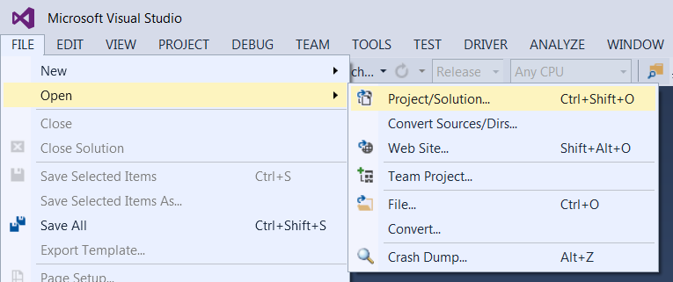

## Build Project

For each of the following configurations, do these steps:

Release

### Select Configuration

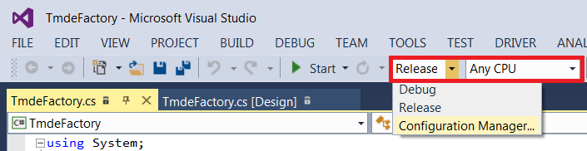Select the configuration using the highlighted drop down menu

### Clean and Build

The Rebuild Solution function will perform a clean and then build.  
Select Build->Rebuild Solution to perform it.

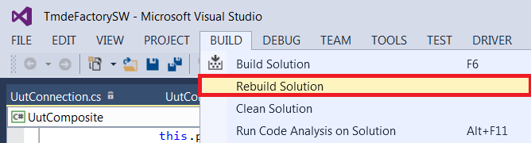

### Verify Warning and Errors

The project should build with no errors. If there are any warnings they should be compared against the list of known warnings the build generates. Any extra warnings should be treated as errors.

The build output window is at the bottom of the compiler

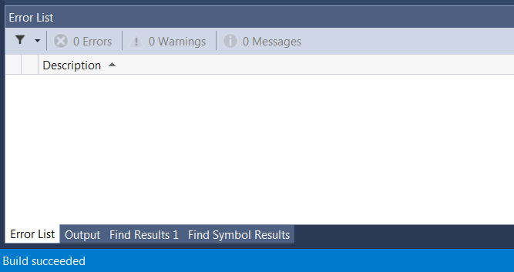

## Copy Build Output

Copy the contents of the \IRIS_TEST_STATION_WS\Apps\TMS\bin\Release folder to the CM area